Company Objectives and Structure

*Trimester 1 2022*

DataBytes

Company Structure and Objectives for T1 2022

# Executive Summary

DataBytes is a multi-disciplinary company that builds next-generation applications and platforms powered by artificial intelligence. At DataBytes we dream big and aim for the stars, so that even when we fail, we fall on the moon.

Our projects facilitate social good, and we pride ourselves on our engineering skills and machine learning knowledge. At DataBytes we prioritise innovation, teamwork, and imagination.

Our portfolio contains several initiatives for the social good including.

* **Discount-Mate** An app that will save Australian householders thousands of dollars every year on their groceries
* **Financial Modeller** Facilitating financial literacy in the general population
* **Dam Analysis and Monitoring (DAM)** Surveying dams and monitoring their greenhouse gas emission to combat climate change
* **Company Website** Developing a company website that will also facilitate student onboarding in future trimesters

The company is directed by Nayyar Zaidi with assistance from the leadership team; Ibrahim Azum, Jorge Leonardo Lemus Castiblanco, Sherley Pidakala and Liz Galanis., who are also running one project each.

Nayyar Zaidi

Table of Contents

Executive Summary 2

Leadership Team 4

Trimester Goals and Objectives 4

Company Structure and Projects Overview 5

Project 1 Discount-Mate 6

Project 2 Financial Modeller Asset Allocation 7

Project 3 Dam Analysis and Monitoring (DAM) 8

Project 4: DataBytes Website 9

# Leadership Team

**Acting Director**

Dr Nayyar Zaidi (<http://www.nayyarzaidi.com>)

**Student Leaders**

Ibrahim Azum

Jorge Leonardo

Liz Galanis

Sherley Pidalka

~~Ross Parkinson~~

# Trimester Goals and Objectives

* Creating an exceptional company website that will also facilitate onboarding students next trimester

***Week 6 Progress Update***

* Creating documentation and processes to enable future trimesters have a seamless transition

***Week 6 Progress Update***

* *Since the first update, a formal policy for onboarding students has been put in place. A flowchart depicting this process can be found in the employee record spreadsheet*

*https://deakin365.sharepoint.com/:x:/s/DataBytes2-Leadership_Team/EVI1lAXFwUtGmwWRHml9kcgBPO9zUaWyJu2B5NrDZciOFA?e=cT8gXk*

* Kickstarting four other major projects, focusing on client communication for high levels of satisfaction

***Week 6 Progress Update***

*All project are up and running, and are on the way to completing deliverables. Individual project updates are outlined below.*

# Company Structure and Projects Overview

**Projects:**

All of DataBytes project’s strive to facilitate social good using machine learning techniques and web development for easy user access. DataBytes has a focus on skilled individuals engineering and harnessing data to its maximum potential.

* **Discount-Mate** An app that will save Australian householders thousands of dollars every year on their groceries
* **Financial Modeller** Facilitating financial literacy in the general population
* **Dam Analysis and Monitoring (DAM)** Surveying dams and monitoring their greenhouse gas emission to combat climate change using high resolution satellite data.
* **Company Website** Developing a company website that will also facilitate student onboarding in future trimesters

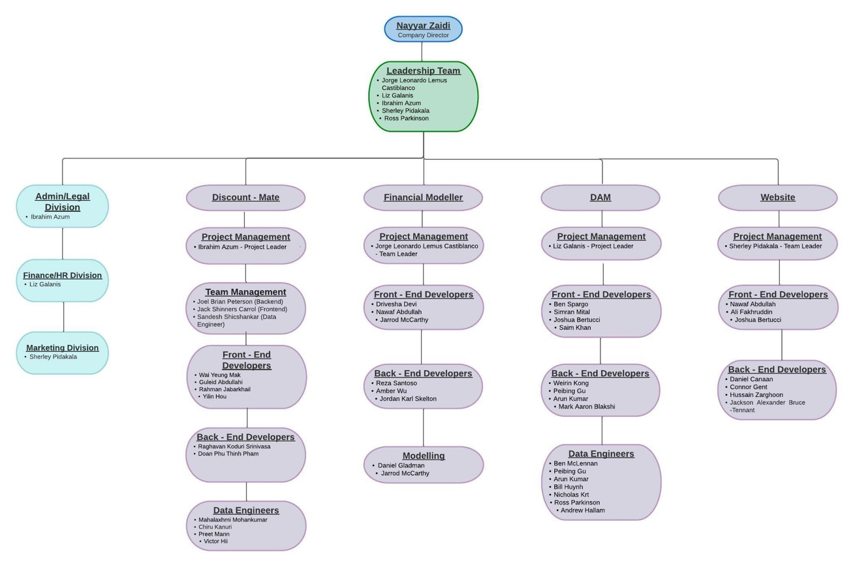

## Project 1 Discount-Mate

#### Overview, Goals, and Objectives

Many big retailers are attracting their consumers through discounts and rewards. Media such as websites, mobile application and other digital and traditional advertisements are some of the tools used by these companies to inform the customers about their deals. Even though customers benefit from these deals, they could get better deals if they have access to information from multiple retailers on one platform. Furthermore, if they can predict potential discounts in advance, customers could save even more by planning their purchases.

This project will create an application that will give customers access to information about discounts from different retailers. Additionally, it will predict future discounts on items. The application will use OCR technology to collect data from consumer receipts and apply machine learning methods to predict the discount patterns.

Short term goal is to develop an application with must have features. Long term goal is to explore and include more features by utilizing the consumer database that is being created.

#### Aims for Trimester

* Research and document product technical architecture, Software requirement specification and Data model structure.
* Build wireframes for front-end.
* Develop a prototype of the application with minimal functionality

#### Deliverables

* A wireframe/mock-up of the user interface that includes login system for consumers and admin users.
* A ML model that will be used for predicting future discounts.
* Implementation of Optical character recognition (OCR) functionality.
* Standard documentation of the product and research outcomes.

#### Project Members

**Seniors:** IBRAHIM AZUM - Project Lead, Technical Lead | SHERLEY PIDAKALA– Team Leader | JOEL BRIAN PETERSON | JACK SHINNERS CARROLL | PREET MANN | VICTOR HII | SIMRAN MITTAL -

**Juniors:** WAI YEUNG MAK |RAGHAVAN KODURI SRINIVASA | GULEID ABDULLAHI | RAHMAN JABARKHAIL | DOAN PHU THINH PHAM | JOSHUA BERTUCCI | YILIN HOU | MAHALAXMI MOHANKUMAR | CHIRU KANURI | SANDESH SHIVSHANKAR

## Week 6 Update for DiscountMate

Development Environments have been setup and frontend, backend and data engineering teams have been working on individual modules as highlighted below:

Front-end: Initial Screens designs on Figma, Registration/Login Screen , Product listing and web admin portal developed. Integration between frontend and backend has been tested. Work on other screens is on-going.

Backend: Main database and user and product API for integration with other modules created. Further development on Database, API and security enhancement development in progress

DB Engineering: Reading Receipt image to text using Tesseract OCR engine tested for one type of receipt. Fine tuning and generalisation work of OCR algorithm is in progress.

Additionally, Github repository for the project has been setup and being used for version control and documentation.

Finally, data collection mechanism for initial dataset ”DiscountMateDataset” has been established and advertised on different channels.

## Project 2 Financial Modeller Asset Allocation

#### Overview, Goals, and Objectives.

Investing online is growing. In the 2021 Australia trading behaviour survey, it was found the number of active online investors keeps rising. One of the main reasons for this increase is the ability of people to invest in small amounts and the constant search for a side hustle. Indeed, people can find this mechanism useful for financial freedom, but it is important to notice that the rate of success in this environment is quite low. Even for professionals, finding consistency and profitability in this environment is hard. This is the hurdle that our project wants to help others overcome.

This project has the general goal of creating financial literacy for everyone. With a pay-subscription service at a competitive price, we offer a series of general tools for financial decisions, improving the choice made by investors in asset allocation. To achieve this service, we will create financial models using Python. The code will extract financial information and find important insights. It will give a list of potential assets to be bought with different levels of risk (high, medium, and low) and different timeframes (3 months, 12 months).

In the short term, our goal is to create a clear structure for the project and a website with the basic features. Furthermore, we will apply different algorithms to create smart portfolios based on our inputs. In the long term, the project will continue adding educational features based on state-of-the-art of asset allocation. Nonetheless, we will keep improving and testing the current algorithms.

#### Aims for Trimester

* Create a subscription base website using the best features of ( <https://www.finviz.com>, <https://www.wallstrank.com/> and <https://www.fool.com.au/services/>)
* Algorithms in charge of find the best possible asset in the market given the tolerance risk from the user.
* Clear documentation supporting the enough information for future deliverables in the project.

#### Deliverables

* Design and deployment of a friendly website for users defining the web language, the right visualization style and the right content -search engine optimization. (SEO) (short term)
* Define clearly how the website is going to work defining the programming language, scripting, server security, scalability and back up. (short term)
* Create at least two different algorithm that classify financial assets with different level of risk (short term).
* Create at least one algorithm in charge of optimize the performance of the different portfolios (short term).
* In the long term the previous features presented must be improved creating more precise algorithms a better user experience and a mobile application.

*Project Members*

* Data Science Team – Jorge Lemus (Senior), Jarrod McCarthy (Senior), Daniel Galdman
* Front End – Nawaf Abdullah (Senior), Drivesha Devi (Senior)
* Back End – Reza Santoso, Jordan Karl Skelton, Amber Wu

## Logo, company name Description automatically generatedLogo, company name Description automatically generatedProject 3 Dam Analysis and Monitoring (DAM)

#### Overview, Goals, and Objectives

**Farm dams are a high source of greenhouse gasses when not properly managed, producing the equivalent of approximately 385,000 cars per day in Victoria alone! Deakin University is leading ground-breaking research into the effects of farm dams on climate change, however, there is currently limited survey data of farm dams in Australia.**

This project will survey farm dams using computer vision techniques in conjunction with high resolution satellite data, the output of which will be used by scientists and policy makers to model the effects on climate change and facilitate sustainable farming practices.

In T3 2021 the Environmental Science Squad created an algorithm which can detect water in high resolution satellite images in Victoria. Our client, Dr Malerba from the Blue Carbon Lab, expects that building on our work from last trimester we will be able to create a scientific writeup to submit for publication this trimester. Our short-term goals are to fix any bugs in our algorithm and close outstanding issues from last trimester, undertake robust testing, create scientific writeup and create an associated web application for easy use. Longer term goals beyond this trimester include more contextual training of the algorithm, expanding our dataset to encompass beyond Victoria, and expand our classifier to assess the water quality of farm dams.

#### Aims for Trimester

* Algorithm refinement and testing, package algorithm in GEE
* Create a user-friendly web app

#### Deliverables

* A web app where users can view the distribution of farm dams in their region (short term)
* An algorithm that detects water on Sentinel 2 satellite data (short term)
* A scientific writeup of our project

#### Project Members

Data Science Team –Nicholas Krt (senior), Liz Galanis (senior), Bill Huynh (senior), Peibing Gu, Ben McLennan ~~Ross Parkinson (senior)~~ and Andrew Hallam (joining part time)

Web Development Team - Arun Kumar (senior), Simran Mittal, Saim Khan, Joshua Bertucci, Mark Aaron Blashki, Weiren Kong and Ben Spargo

#### DAM Week 6 Project Update

The DAM project is on track to release an alpha version of the web app by the end of week six (end of the first iteration). We are also on track to release a new version of the training data at this time, which will improve the efficiency of the water/land classifier algorithm created last trimester. There have been no changes to the plan for this project. Gantt charts are shown below.

## Project 4: DataBytes Website

#### Overview, Goals, and Objectives

This project is essentially a website for DataBytes Company. Which will have the basic information of who we are as a company, what we do, and what projects we have running now. It will also have the list of jobs we have available for the company and what projects they are available in. The website will also have a page will list of employees that are currently in this and what project they are in. We aim to develop a feature for the admins to login such as a HR to be able to login and edit the projects, employee records and jobs availability. We plan on building this website with various technology for both front and back end.

The long – term goal for this project is to have a fully functioning website for DataBytes that will attract clients that would want to take us up for projects and we are able to expand this company and are able to take off as a successful company.

The short-term goal for this project is to have solid template of the website and have a foundation for the website

#### Aims for Trimester

* Build a template for the website.
* Have a foundation build for the website.
* Get documentation ready as to how to go forward and build on this project for the next trimester

#### Deliverables

* A template on how the website should look like and what type of colour palette, font and how to respectfully display all the essential information we need to have.
* The foundation for this project we are planning on using is Bootstrap, Django and a few other essential technologies.

#### Project Members

Project Lead: Sherley Pidakala

Back-end developers:

* Connor Gent
* Daniel Canaan
* Jackson Alexander Bruce-Tennant
* Kiet Lam

Front-end developers:

* Joshua Bertucci
* Ali Fakhruddin
* Hussain Zarghoon

|  |
| --- |
| Website Week 6 Project Update The website project is on track |
|  |